# INTRODUCTION

Due to the uncertainty between impedance and admittance control, we wanted to test a wide variety of different prototypes while the actuator team worked to add context to this issue. We also were able to categorize our prototypes into 4 concepts, with 2 categories for each one: parallel and serial. We focused on iterating among the prototypes to identify the best concept and sub-category for the integrated prototype. The following table shows the conclusion reached after refining concepts:

| **Concept** | **Gantry** | **Cable** | **Open Linkage** | **Closed Linkage** |
| --- | --- | --- | --- | --- |
| **Parallel** | Concerns with the amount of friction in the gantry system, especially with binding; could work well if singularities pose too much of an issue for the linkage solutions | Requires 6+ motors, 3+ for each magnet; no way for magnets to exist at similar heights due to interference of cables; stacking of magnets would be a significant issue | Low friction due to only having revolute joints makes it very backdrivable and smooth, so it is probably the best option for impedance control; concerns with singularities and cross over of points | Would require 8 links, 4 per system; difficult to justify using closed linkage system over open linkage system due to having larger mass and greater potential interference due to more links |
| **Serial** | Concerns with mass of system not allowing us to hit our free-motion inertia requirement, but it is likely the best option if actuator team finds that admittance control is preferred over impedance control | With end effector mass being equal, the cables have the least mass which makes them well-suited for impedance control; concerns with how to maintain proper tension in all cables while preserving backdrivability | Similar concerns as parallel with singularities and manipulability; can still anchor both joint actuators to ground using belts for less inertia and better impedance control | Limited workspace due to singularities; |

| **Concept** | **Discussion** |
| --- | --- |
| **Disks** | There will be significant backlash in the disks when directions are changed; part tolerances required for smooth motion not reasonable for manufacturing in-house |
| **Motor** | Basic attachment of motor is simple for control and mechanical design; concerns with higher torques requiring high gear ratio that limits backdrivability for impedance control; unable to anchor motor to ground so there are concerns with finding a light enough motor to meet free-motion inertia requirement |
| **Motor+cable** | Anchoring the motor to ground helps reduce the inertia of the end effector to meet free-motion inertia requirement; concerns with lots of belt routing that adds friction and harms backdrivabiltiy |

# A. MAGNETS

### Description

The magnets are the key element of our prototype for they have the final say on the user’s haptic experience. For the purpose of this application, we will be looking to find magnet solutions that can offer us low friction and strong shear forces - helping us emulate the sensibility of navigating a touchscreen, while being able to produce the necessary shear force to translate the haptic experience. In this exploration we will be looking at different magnets and magnets arrangements, as well as the inclusion of different aiding devices and technologies to help us reach the desired effect.

## PROTOTYPE 1

### Plan & Questions

For our initial prototype we just want to get familiarized with different magnets and magnet systems and try to narrow down a list of selected few that closely match our needs. To do this we will be ordering a large variety of magnets from different manufacturers and in a range of materials. We will also be experimenting with the idea of polymagnets by creating some of our own by arranging small magnets into unique patterns press fitted into a 3D printed custom housing, followed by ordering some from specialized manufacturers.

When evaluating we will be looking at 3 main factors:

1. Friction - we need the smallest friction we can get for neutral hand movement
2. Attractive Force - we need sufficient force to keep magnets connected through the screen
3. Shear Force - we need strong shear force, enough to mimic a wall effect (~10N)

### Results

*Figure 1. Layout of all magnets for testing*

| Reference | Magnet type | Results |
| --- | --- | --- |
| 5857K11 | Ceramic magnet ¼’’ thick | Friction: Ideal  Attractive Force: Moderate  Shear Force: Weak |
| 5857K25 | Ceramic magnet 1/8’’ thick | Friction: Ideal  Attractive Force: Moderate  Shear Force: Weak |
| DIY_V1 |  | Friction: Ideal  Attractive Force: Moderate  Shear Force: Moderate/Weak |
| DIY_V2 |  | Friction: Ideal  Attractive Force: Moderate  Shear Force: Moderate/Weak |
| 2494N9 | ⅛” thick | Friction: Moderate  Attractive Force: Ideal  Shear Force: Moderate |
| 2494N11 | 3/16” thich | Friction: Moderate  Attractive Force: Ideal  Shear Force: Moderate |
| 1002260  1002261 |  | Friction: Moderate  Attractive Force: Ideal  Shear Force: Moderate/Strong  For 1.5mm magnet-to-magnet gap:  Attract force ~20N when aligned  With ~2mm horizontal displacement, attract force drops to ~10N and shear force is ~9N |
| 1000575 |  | Friction: Moderate  Attractive Force: Ideal  Shear Force: Moderate/Strong  For 1.5mm magnet-to-magnet gap:  Attract force 18.5N when aligned  With ~2mm horizontal displacement, attract force drops to ~11N and shear force is ~8N |
| 1000567 |  | Friction: High  Attractive Force: Too strong  Shear Force: Ideal  For 1.5mm magnet-to-magnet gap:  Attract force 32.3N when aligned  With ~2mm horizontal displacement, attract force drops to 21.7N and shear force is 13.6N |
| 1000563 |  | Friction: High  Attractive Force: Too strong  Shear Force: Ideal  For 1.5mm magnet-to-magnet gap:  Attract force 58.1N when aligned  With ~2mm horizontal displacement, attract force drops to 19N and shear force is 24.6N |
| 1000423 |  | Friction: High  Attractive Force: Too strong  Shear Force: Ideal  Note: given the square configuration it is easy to malposition the combined magnets |
| 1000435 |  | Friction: High  Attractive Force: Too strong  Shear Force: Ideal  Note: given the square configuration it is easy to malposition the combined magnets |
| 1000425 |  | Friction: High  Attractive Force: Too strong  Shear Force: Ideal  Note: given the square configuration it is easy to malposition the combined magnets |
| 1000628 |  | Friction: High  Attractive Force: Too strong  Shear Force: Ideal |

### Analysis & Next Steps

From this initial exploration we realized that polymagnets offer more competitive properties when it comes to a small amount of inertia and strong shear forces. The DIY polymagnets were a good initial exploration, but ultimately the magnets from Polymagnet, particularly the round ones, have stood out for their properties. Next steps will involve the exploration of ways to decrease friction - by contacting experts from Polymagnet and asking for custom magnets or suggestions from their current catalog; and by working with different low friction materials such as teflon.

## 

## PROTOTYPE 2

### Plan & Questions

For this second iteration we are hoping to improve the characteristics of our magnet selection by introducing different devices and technologies that could help reduce their friction. Therefore, the leading question for this prototype is if external elements can help significantly reduce friction within our magnet selection, and if so which.

For this initial testing round we will be exploring teflon tape, teflon balls and felt.

### Results

### *Figure 2. Placement of teflon balls on the magnet housing for a polymagnet and a DIY polymagnet*

| Reference | Material | Results |
| --- | --- | --- |
| 1 | Teflon tape | Friction was significantly reduced, both when applied onto the screen or the magnet |
| 2 | Teflon balls | Friction was reduced, not as effectively as the tape, but appears to be a better solution in terms of practicality |
| 3 | Felt | Friction wasn’t significantly impacted |

### Analysis & Next Steps

Additional low friction elements are effective in reducing friction from magnets and should be incorporated into the design. So far the most effective approach, for our design, has been to use both the teflon balls and the teflon tape which proves better than any one solution on its own. For the future, we still want to explore some other alternatives including the use of grease and air bearings.

# B. GANTRY

### Description

The gantry is the first idea our group came up with when brainstorming and was easy to construct using parts from an Ender3 3D printer, all of which can be found and purchased online. This gantry used v-grooved wheels on v-slot extrusions. Most parts were from the original 3D printer however some custom parts were constructed in order to remove heavy brackets and add an additional axis.

## PROTOTYPE 1

### Plan & Questions

Plan: Use stock Ender3 printer components to construct a 4 DOF system that could incorporate 2 magnets in parallel. To accomplish this all redundant components were removed from the stock printer (heavy metal plates, the printer head, etc) and necessary components were redesigned to reduce weight. The current y-axis was duplicated to add two more degrees of freedom.

Questions:

1. After manually feeling other 3D printers around Ford (Ultimakers, Prusas), can we construct a prototype that can successfully reduce the friction enough to be viable in a haptic device?
2. Will a gantry bind when loads are applied at various distances away from the rails?

### Results

The Ender3 wheels slide better when loaded radially (compared to axially loaded as in the original Ender3 design) so each of the mounting plates was redesigned to accommodate this switch. There were several iterations on the mounting plates/hardware in order to ensure proper alignment and reduce friction. The prototype continued to build on itself so there were no definitive/noteworthy versions apart from the final product.

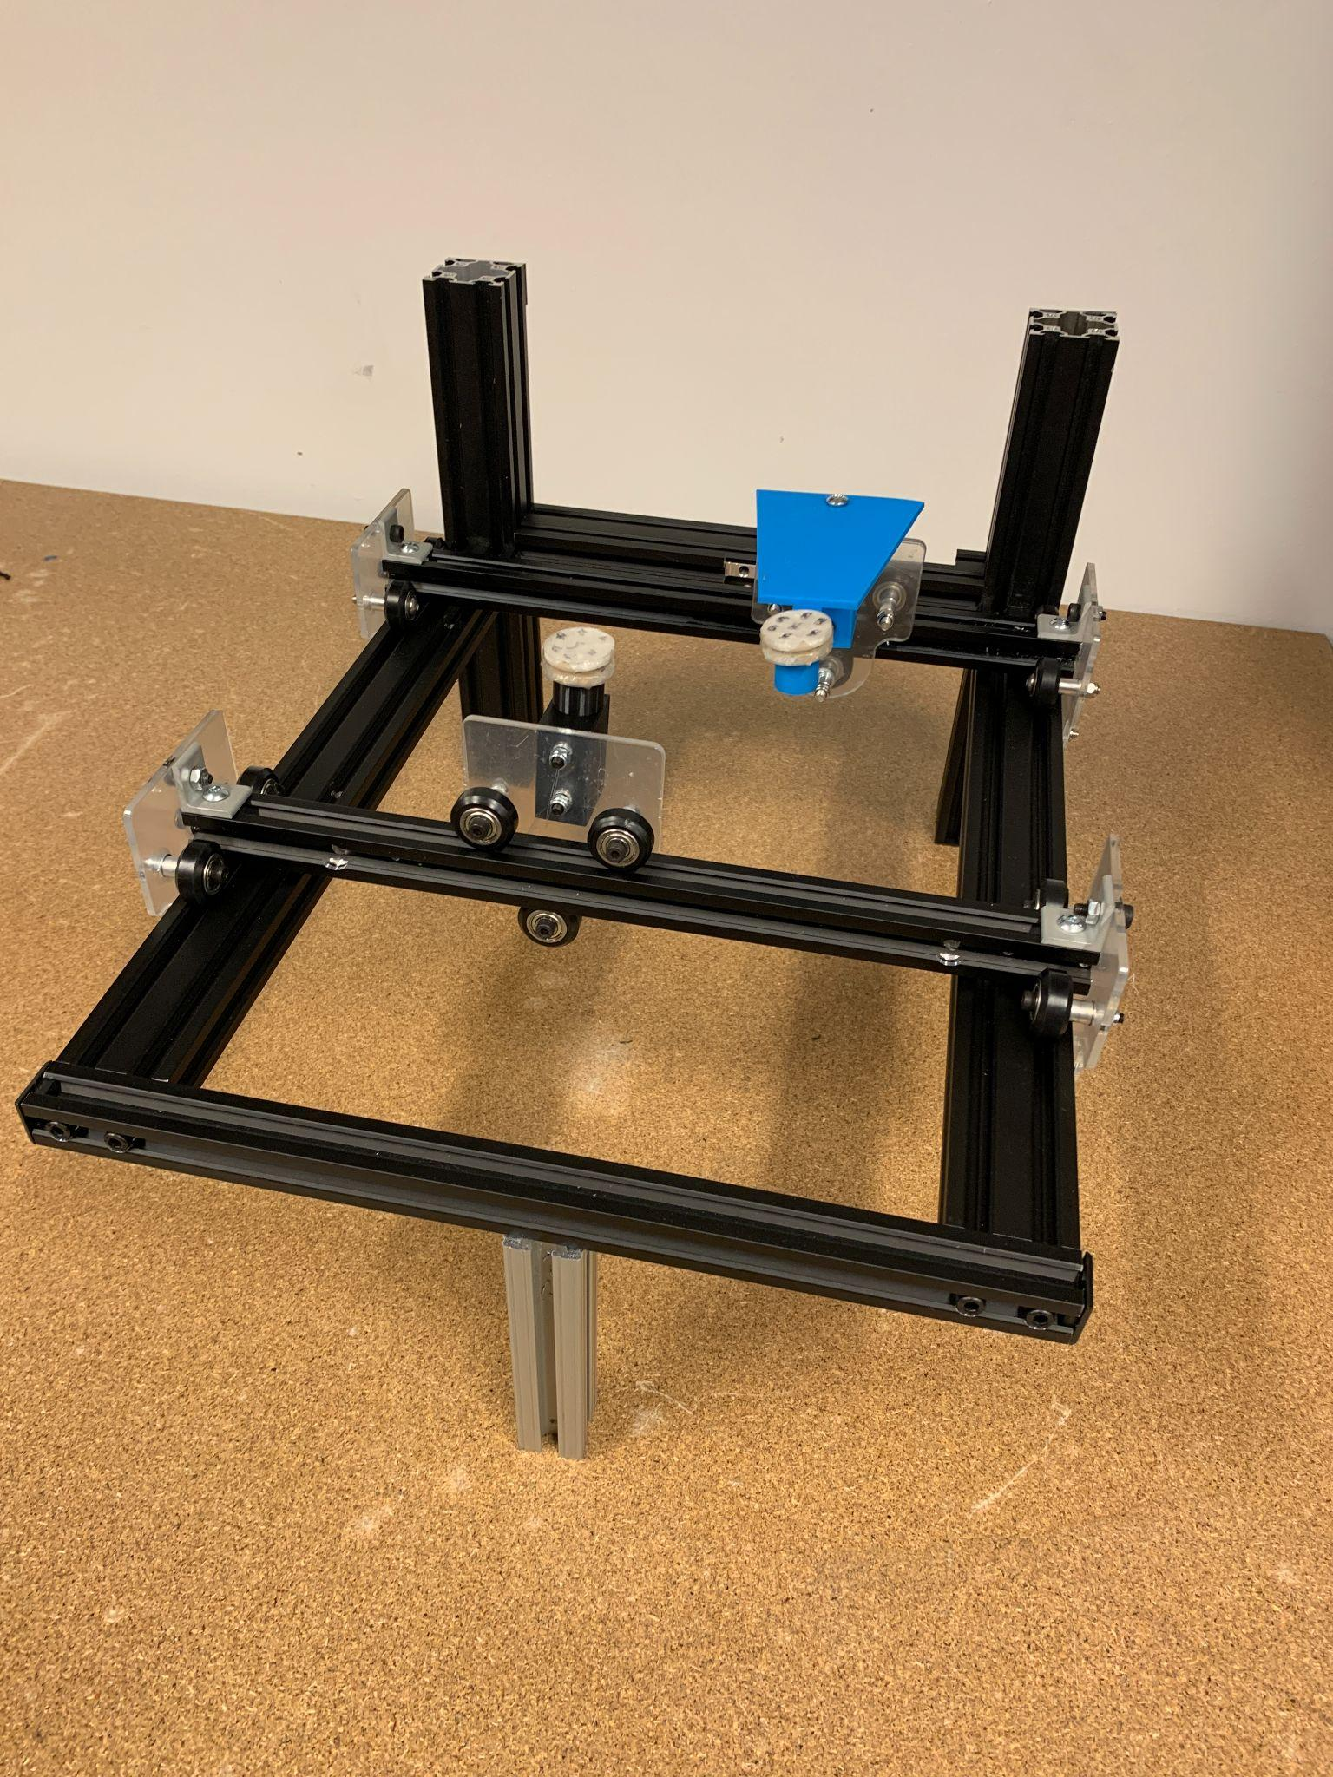

*Figure 3: Gantry Prototype*

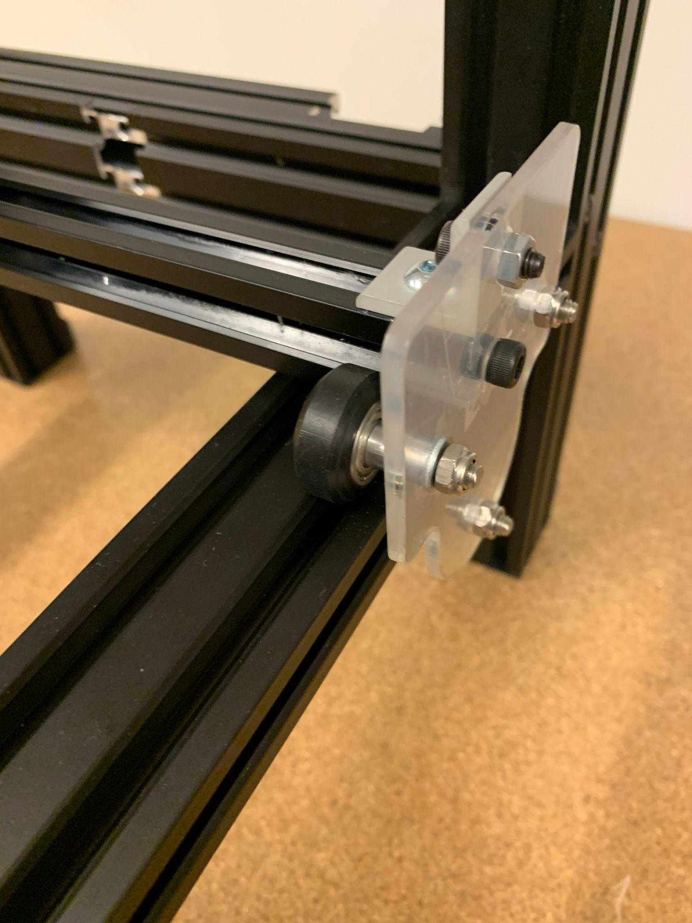

*Figure 4: Redesigned Mounting Plates*

Constructing the gantry proved to be more difficult than originally thought due to the amount of adjustability in the system. Each mounting bracket has one eccentric nut that can be CAMed to ensure proper wheel spacing on the extrusions. With a total of six brackets there were 6 different points of adjustment, each of which would have large effects on the amount of friction/binding that occurred in the system.

With the eccentric nut too tight, the system would have lots of friction that would make it unusable. With the nut too loose, binding would occur due to moments applied on the axis. Furthermore, the bolt holding the wheels can also be too tight (compressing the inner race creating friction) or too loose(causing the wheel to lose concentricity about its axis). On one of the axes, a sweet spot could be found for all of these parameters after a lot of tuning.

However, using the exact same hardware, the major axes of the prototype felt different. No matter how much the CAM nuts, bolt torque, and spacing were adjusted, the second axis was unable to achieve friction comparable to the first axis. The friction on the second axis was not horrible and when paired with magnets, the friction between the magnets and the screen was still the biggest issue.

### Analysis & Next Steps

This style of gantry using the v-grooved wheels/extrusions consists of a lot of mechanical adjustment that can cause many headaches later in our final design. While other styles of gantry are possible that would reduce this adjustability, such as a CoreXY cable style or linear sliders, our other prototypes proved more promising, eliminating the need to further pursue the gantry.

### 

# C. CABLE BOT

### Description

The cable bot relies on cable tensioning to position the end effector across the x-y plane. We want to explore with this prototype how friction is affected at different points of the frame, how feasible it is to sustain constant tension on all cables and if the carriage’s weight affects positional accuracy.

## PROTOTYPE 1

### Plan & Questions

The main questions we are hoping to answer are the ability to reach all necessary points within the workspace, the positional accuracy of the prototype given the weight of the carriage, the variances in friction throughout the screen, and the tensioning of the cables.

To address these questions we are developing a physical prototype using four of the rack retractable cable pulleys allies to a custom carriage with a spinning axis where our two magnets will be connected to. The prototype will also be allied with an acrylic screen to represent the workspace. We intend to make our initial assessments, regarding the questions asked, by exploring the motion of the carriage, manually, within this prototype.

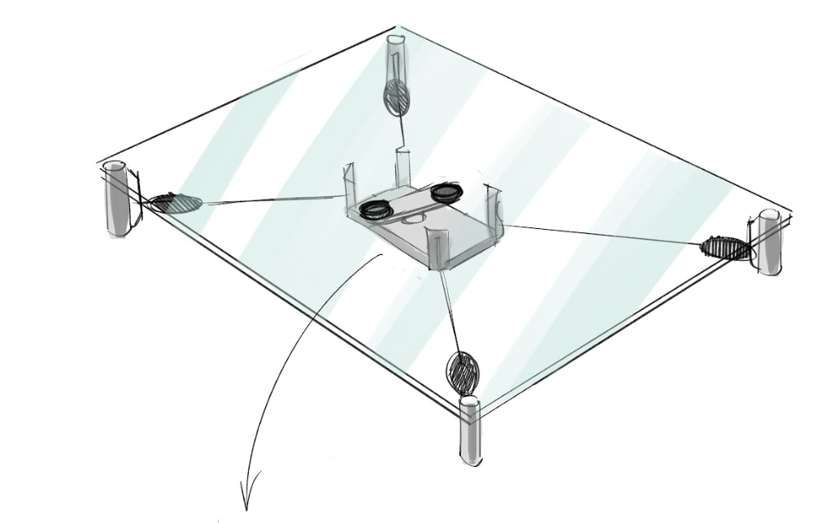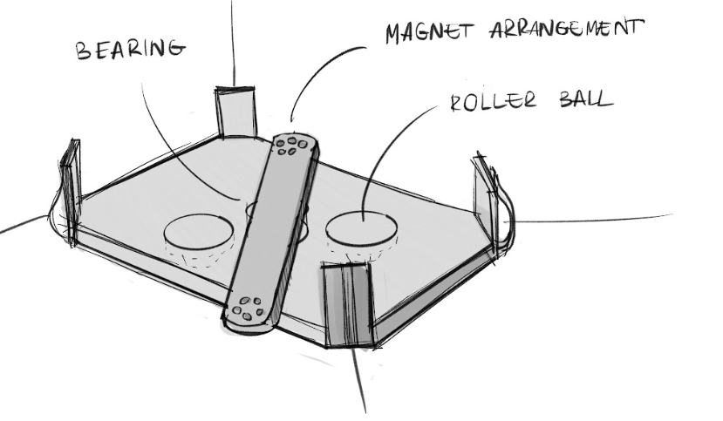

### 

*Figure 5: Prototype sketches for the cable bot*

### 

### Results

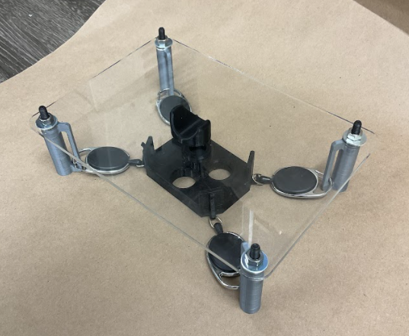

*Figure 6: Cable bot (recreated for documentation purposes - originally on a bigger screen)*

The resulting prototype was able to reach all the points of the screen but we found that controlling the torque of the end effector was challenging for this particular design. Similar to why a helicopter needs a tail rotor, the cables would have to be able to counteract any torque applied by the central motor. Furthermore, even though this was a low-fidelity prototype with some off the rack retractable cable pulleys, it became apparent the challenges of keeping the right tension throughout all four axes.

**Analysis & Next Steps**

We have decided not to pursue this solution. While the idea had some merit, the complexity of the design to ensure it met our specs and the additional amount of motors needed, when compared to the other solutions we were working with such as the 2R bot and the gantry, made this design sub-par and not worth pursuing.

# D. OPEN-CHAIN LINKAGE

### Description

We think there’s lots of potential with the open-chain linkage mechanism, as it uses only rotational joints instead of linear ones, helping to minimize the friction in the device. Minimizing the friction really helps with impedance control, as it should make the mechanism very backdrivable. However, the open-chain linkage has a lot of unknowns regarding workspace and manipulability, as the advantages of low friction are null when the arm is at a singularity, since it then becomes impossible to move in one direction.

## PROTOTYPE 1

### Plan & Questions

To get a feel for the size and manipulation of the open-chain linkage, we will create a simple prototype made from acrylic links of which we can change the lengths and relative position.

* What do the singularities feel like?
* How does movement feel near singularities?
* What do the arm configurations look like throughout the workspace? Is it consistent?

### Results

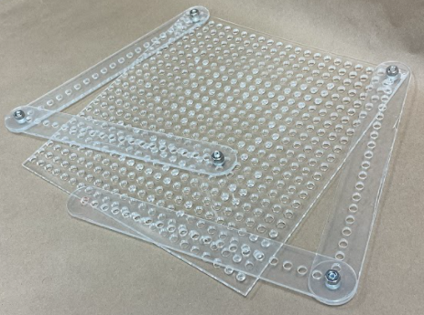

*Figure 7: Image of acrylic link system.*

* Free motion is reasonable here, as there isn’t much friction between the joints between the links and the nuts holding them together, provided they aren’t overly tightened.
* Singularities feel very bad, and it’s quite obvious once you reach one. There is a risk of snapping into an incorrect orientation as well.
* Hard to test the links overlapping one another, since they are assembled on the same plane.

### Analysis & Next Steps

With a general understanding of the workspace and manipulability, we can take it a step further and mathematically determine the condition number within our workspace to construct reasonably sized physical prototypes later.

## PROTOTYPE 2

### Plan & Questions

To begin answering questions about workspace and manipulability, we will develop a script in Python that can take a parameterized version of the open-chain linkage and create a 2D color-plot over the workspace (the size of the tablet/touch screen) of the condition number at the end-effector of the 2R robot.

* What order of magnitude of length will the links need to be in order to have a relatively uniform condition number across the screen?
* Where do the singularities appear the most along the screen? Near the edges? Near the corners?
* What does the ideal case look like? Is it possible to have a condition number of nearly 1 across the entire workspace?

### Results

Table 1 shows the results of the plotting. A simple sketch in SolidWorks was used to visualize different parameter combinations. The left side of the table shows that sketch with the links highlighted in blue, and the right side shows the condition number as a function of position inside the workspace.

| **No.** | **Geometry** | **Condition Number within Boundary** |
| --- | --- | --- |
| 1 |  |  |
| 2 |  |  |
| 3 |  |  |
| 4 |  |  |
| 5 |  |  |

* There will definitely need to be some space between the base of the links and the bottom of the screen, as shown in case 5
* The highest condition numbers appear nearest the base of the arm and the opposite corners, as shown in case 1 and 2
* Large enough links impose a very uniform condition number across the workspace, as shown in case 3

### Analysis & Next Steps

These plots are extremely helpful in determining reasonable geometry for use with the open chain linkage, and how to select parameters (i.e. the location of the base of the arm and the lengths of the links) for a first physical prototype that are closest to the ideal configuration.

Yet, with no physical prototype, it’s impossible to contextualize a condition number in the physical sense of how it feels. A condition number of 1 is ideal, but is a condition number of 2 tolerable? What about 3? 5? 10? The plots show that the longer links have better performance, but too long of links creates a lot of deadspace around the touch screen. We want to find the maximum condition number that is usable to minimize the size of the arms.

## PROTOTYPE 3

### Plan & Questions

Using the results from prototype 2, we can construct a physical prototype to explore manipulability, singularities, the interaction with a screen. Utilizing 3D printing and basic hardware. Particularly, we want to see at what condition number the user can identify poor haptic effects. This means that a configuration similar to case 2 in the previous prototype was chosen, as it had a large range of condition numbers across the workspace.

### Results

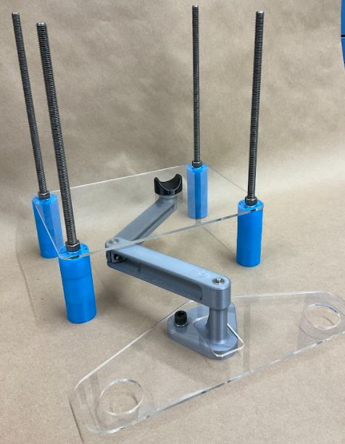

*Figure 8: V2 of the open chain linkage prototype*

* The arm on its own feels quite good in free motion. The rotary joints with bearings have greatly reduced friction and it has much less friction than any other design.
* The arm can easily reach all point within the workspace
* The friction between the magnet and screen still poses the greatest challenge, and it has too large of impedance to test the effect of condition number on free motion.
* No condition numbers can be evaluated with large friction in the magnets

### Analysis & Next Steps

The only major issue is the friction between the magnets and the screen, otherwise it has proven to function better than any other prototypes. The extremely low friction and inertia combined with the correct setup of mounting location/link length, demonstrates this design's viability for our final solution. The next steps are to think about how each joint is going to be driven and integrate/duplicate this subsystem to hold two magnets.

# E. CLOSED-CHAIN LINKAGE

### Description

With this variation of the chain linkage we are hoping for a stronger stability to the system as a whole and an improvement on positional accuracy. In this particular concept we are focused on using a closed chain linkage with one end effector. Our main challenge with this particular prototype will be finding a way to reach all points of the frame while avoiding singularities.

PROTOTYPE 1

### Plan & Questions

We will be using the same initial prototype used for the chain linkage but this time around we will constrain the ends of each arm.

The main questions we have regarding this initial prototype are its effectiveness in reaching all points in its workspace, and its ability to do so while avoiding singularities.

### 

### 

### 

### 

### 

### Results

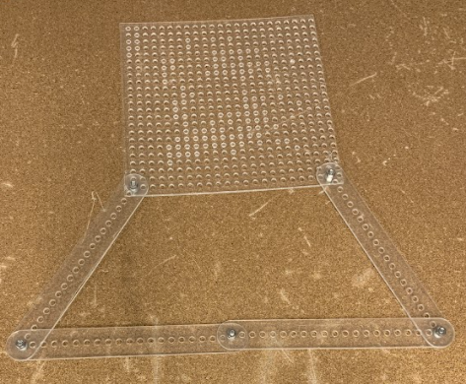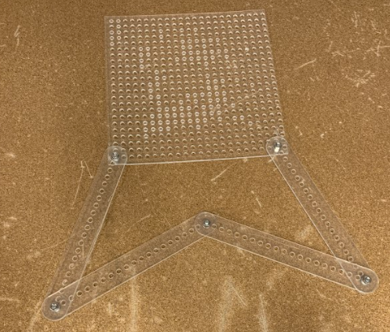

*Figure 9: Closed chain linkage prototype*

From this initial prototype we were able to understand the limitations incurred to avoid singularities. This is, while we were able to set up a work frame where the prototype was able to navigate whilst avoiding singularities, that came at the price of using rather large arms for the proportion of said frame, which in turn affected position accuracy and torque.

### Analysis & Next Steps

We will not pursue this particular design given its constraints and lack of added benefits when compared to the other prototypes being explored - particularly the open chain linkage.

# CONCLUSION

After all prototyping, this is the current updated table from Part 1 of this assignment:

GREEN: Still a possibility

RED: Idea was excluded

| **Concept** | **Gantry** | **Cable** | **Open Linkage** | **Closed Linkage** |
| --- | --- | --- | --- | --- |
| **Parallel** | Concerns with the amount of friction in the gantry system, especially with binding; A lot of mechanical adjustability that doesn’t demonstrate clear benefits over other designs | Requires 6+ motors, 3+ for each magnet; no way for magnets to exist at similar heights due to interference of cables; stacking of magnets would be a significant issue | Low friction due to use of rotary joints over linear; can control each of the two arms using fixed motors at the base and belt systems; | Would require 8 links, 4 per system; difficult to justify using closed linkage system over open linkage system due to having larger mass and greater potential interference due to more links |
| **Serial** | Concerns with mass of system not allowing us to hit our free-motion inertia requirement, but it is likely the best option if actuator team finds that admittance control is preferred over impedance control | With end effector mass being equal, the cables have the least mass which makes them well-suited for impedance control; concerns with how to maintain proper tension in all cables while preserving backdrivability | Similar concerns as parallel with singularities and manipulability; can still anchor both joint actuators to ground using belts for less inertia and better impedance control | Limited workspace due to singularities; requires motors at the end effector to drive final two degrees of freedom, so there is increased inertia |

| **Concept** | **Discussion** |
| --- | --- |
| **Disks** | There will be significant backlash in the disks when directions are changed; part tolerances required for smooth motion not reasonable for manufacturing in-house |
| **Motor** | Eliminated due to increased mass and feasibility of parallel mechanisms |
| **Motor+cable** | Eliminated due to complexity and feasibility of parallel mechanisms |